1. Homarus is classified into which phylum?
a. Annelida
*b. Arthropoda
c. Chordata
d. Cnidaria
e. Platyhelminthes

2. Homarus have which type of symmetry?
*a. bilateral
b. radial

4. Homarus exhibit cephalization.
*a. true
b. false

5. Homarus have
*a. a complete digestive system
b. a gastrovascular cavity

6. Which animal is not a member of the same phylum as crustaceans?
a. insects
b. horseshoe crabs
*c. snails
d. trilobites
e. spiders

7. What type of nervous system is found in Homarus?
a. anterior pair of ganglia with ventral nerve cords
*b. brain, ventral nerve cords, and segmental ganglia
c. complex folded brain, spinal cord and nerves
d. nerve net

8. Is Homarus diploblastic or triploblastic?
a. diploblastic
*b. triploblastic

9. Which type of excretory system is present in Homarus?
a. kidneys
b. metanephridia
c. protonephridia
*d. antennal glands
e. no excretory system is present

10. On the lobster picture below, the structure labeled “a” is the

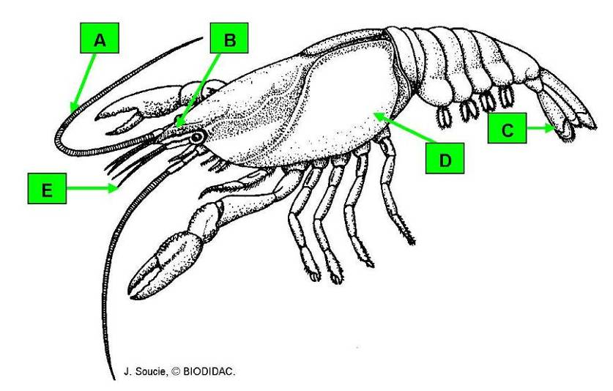

*a. antenna (2nd pair)
b. antennule (1st pair)
c. carapace
d. rostrum
e. uropod

11. On the lobster picture below, the structure labeled “b” is the

a. antenna (2nd pair)
b. antennule (1st pair)
c. carapace
*d. rostrum
e. uropod

12. On the lobster picture below, the structure labeled “c” is the

a. antenna (2nd pair)
b. antennule (1st pair)
c. carapace
d. rostrum
*e. uropod

13. On the lobster picture below, the structure labeled “d” is the

a. antenna (2nd pair)
b. antennule (1st pair)
*c. carapace
d. rostrum
e. uropod

14. On the lobster picture below, the structure labeled “e” is the

a. antenna (2nd pair)
*b. antennule (1st pair)
c. carapace
d. rostrum
e. uropod

15. On the lobster picture below, the structure labeled “a” is the

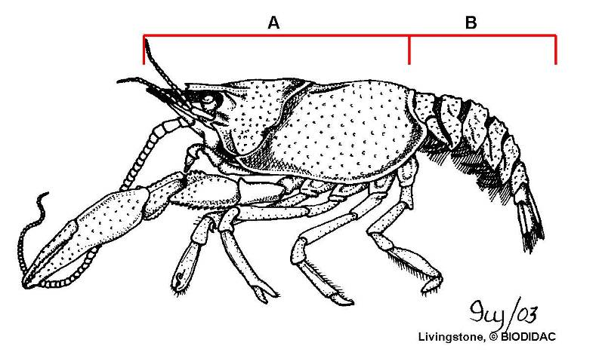

a. abdomen
*b. cephalothorax

16. On the lobster picture below, the structure labeled “b” is the

*a. abdomen
b. cephalothorax

17. On the lobster picture below, the structure labeled “a” is the

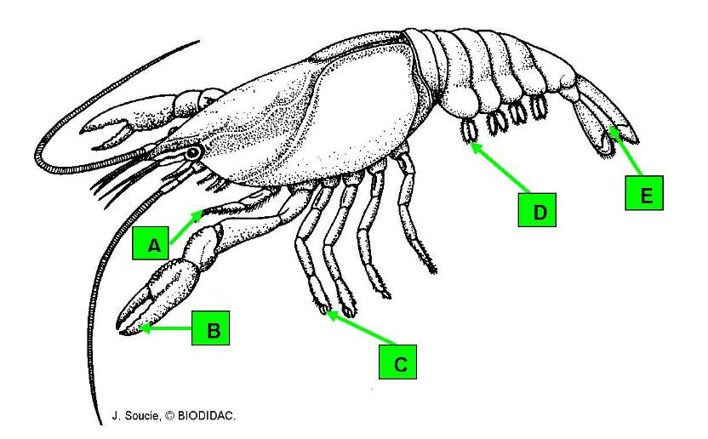

a. cheliped
*b. maxilliped
c. swimmeret
d. telson
e. walking leg

18. On the lobster picture below, the structure labeled “b” is the

*a. cheliped
b. maxilliped
c. swimmeret
d. telson
e. walking leg

19. On the lobster picture below, the structure labeled “c” is the

a. cheliped
b. maxilliped
c. swimmeret
d. telson
*e. walking leg

20. On the lobster picture below, the structure labeled “d” is the

a. cheliped
b. maxilliped
*c. swimmeret
d. telson
e. walking leg

21. On the picture below, the structure labeled “e” is the

a. cheliped
b. maxilliped
c. swimmeret
*d. telson
e. walking leg

22. On the lobster picture below, the structure labeled “a” is the

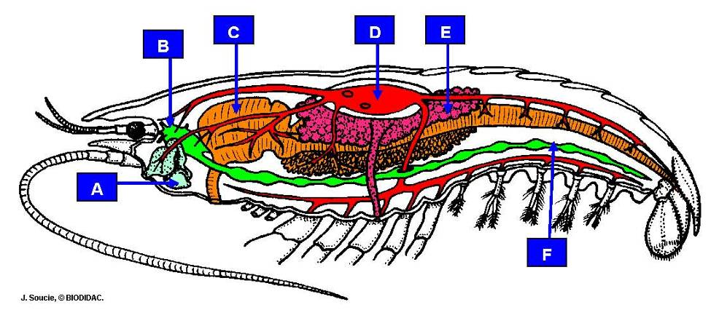

a. brain
*b. green gland
c. heart
d. nerve cord
e. ovary
f. stomach

23. On the lobster picture below, the structure labeled “b” is the

*a. brain
b. green gland
c. heart
d. nerve cord
e. ovary
f. stomach

24. On the lobster picture below, the structure labeled “c” is the

a. brain
b. green gland
c. heart
d. nerve cord
e. ovary
*f. stomach

25. On the lobster picture below, the structure labeled “d” is the

a. brain
b. green gland
*c. heart
d. nerve cord
e. ovary
f. stomach

26. On the lobster picture below, the structure labeled “e” is the

a. brain
b. green gland
c. heart
d. nerve cord
*e. ovary
f. stomach

27. On the lobster picture below, the structure labeled “f” is the

a. brain
b. green gland
c. heart
*d. nerve cord
e. ovary
f. stomach

28. On the lobster picture below, the structure labeled “a” is the

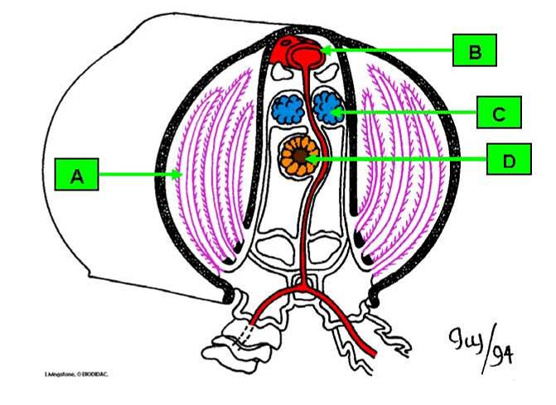

a. digestive tract
*b. gill
c. gonad
d. heart

29. On the lobster picture below, the structure labeled “b” is the

a. digestive tract
b. gill
c. gonad
*d. heart

30. On the lobster picture below, the structure labeled “c” is the

a. digestive tract
b. gill
*c. gonad
d. heart

31. On the lobster picture below, the structure labeled “d” is the

*a. digestive tract
b. gill
c. gonad
d. heart

